Assadullah

Reg # 122393

BSCS-5C

Introduction:

In this lab we learnt to analyse the data of the Airpassengers we analysed the most profitable month from the data of 12 years also found the most profitable year and company’s growth rate over the 12 year period and also found the highest revenue month and highest revenue year and also found the trends of months etc

GitHub link:

TASK1

1(a) Find the most profitable month in the 12 years’ data

Code

# extracting each row to calculate the overall month growth from the data first we create matrix then sum each column

s<-matrix(AP, nrow=12, ncol=12, byrow=TRUE)

s

c1<-sum(s[ ,1])

c2<-sum(s[ ,2])

c3<-sum(s[ ,3])

c4<-sum(s[ ,4])

c5<-sum(s[ ,5])

c6<-sum(s[ ,6])

c7<-sum(s[ ,7])

c8<-sum(s[ ,8])

c9<-sum(s[ ,9])

c10<-sum(s[ ,10])

c11<-sum(s[ ,11])

c12<-sum(s[ ,12])

sumOfMonths<- c(c1,c2,c3,c4,c5,c6,c7,c8,c9,c10,c11,c12)

sumOfMonths

barplot(sumOfMonths, main="graph of Air passengers of 12 months of 12 years", xlab="months", ylab="passengers", names.arg = c("Jan", "Feb","Mar","Apr","May","Jun","Jul","Aug","sep","Oct","Nov","Dec"))

graph

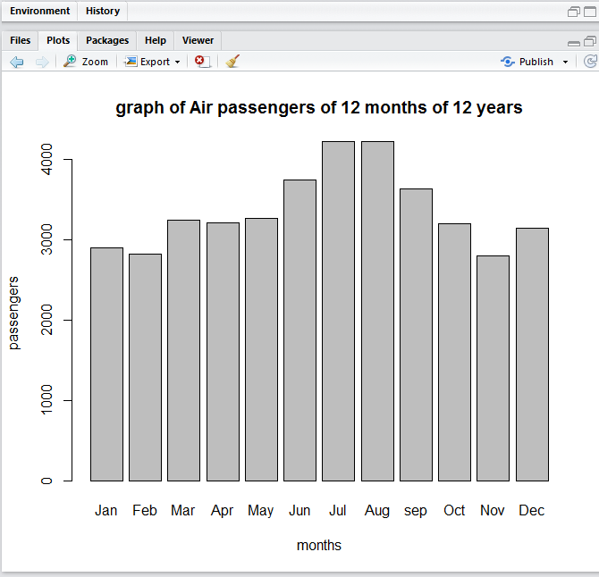



From the above graph and sum of months the most profitable month in 12 years of data is **JULY** in which 4216 passengers travelled

1(b). The most profitable year in 12 years

data("AirPassengers")

AP <- AirPassengers

AP

#extracting each row and calculating the sum of each row and storing in variables

AP[1:12]

a<-sum(AP[1:12])

a

AP[13:24]

b<-sum(AP[13:24])

AP[25:36]

b

c<-sum(AP[25:36])

c

AP[37:48]

d<-sum(AP[37:48])

AP[49:60]

d

e<-sum(AP[49:60])

e

AP[61:72]

f<-sum(AP[61:72])

f

AP[73:84]

g<-sum(AP[73:84])

g

AP[85:96]

h<-sum(AP[85:96])

h

AP[97:108]

i<-sum(AP[97:108])

i

AP[109:120]

j<-sum(AP[109:120])

j

AP[121:132]

k<-sum(AP[121:132])

k

AP[133:144]

l<-sum(AP[133:144])

l

sumOfYears <- c(a,b,c,d,e,f,g,h,i,j,k,l)

sumOfYears

barplot(sumOfYears, main="graph of Air passengers of 12 years", xlab="Years", ylab="passengers", names.arg = c("1949", "1950","1951","1952","1953","1954","1955","1956","1957","1958","1959","1960"))

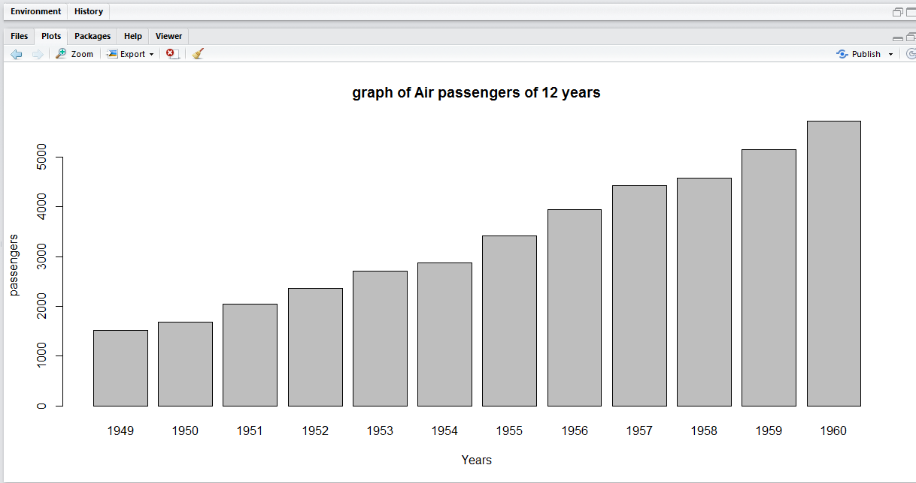

So from the above graph we get the most profitable year is 1960 in which 5714 passengers travelled

1(c) find the growth rate in the 12 years of data of the company is

Plot(AP)

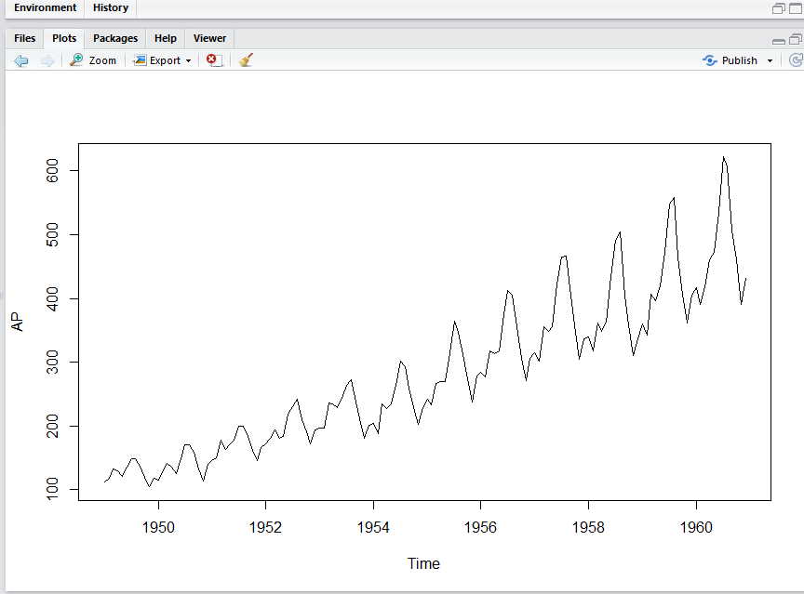

TASK 2

(a)

s<-matrix(AP, nrow=12, ncol=12, byrow=TRUE)

s

rate=8000

c1<-sum(s[ ,1])

s1<-c1*rate

c2<-sum(s[ ,2])

rate<-rate*1.1

s2<-c2*rate

c3<-sum(s[ ,3])

rate<-rate*1.1

s3<-c3*rate

c4<-sum(s[ ,4])

rate<-rate*1.1

s4<-c4*rate

c5<-sum(s[ ,5])

rate<-rate*1.1

s5<-c5*rate

c6<-sum(s[ ,6])

rate<-rate*1.1

s6<-c6*rate

c7<-sum(s[ ,7])

rate<-rate*1.1

s7<-c7*rate

c8<-sum(s[ ,8])

rate<-rate*1.1

s8<-c8*rate

c9<-sum(s[ ,9])

rate<-rate*1.1

s9<-c9*rate

c10<-sum(s[ ,10])

rate<-rate*1.1

s10<-c10*rate

c11<-sum(s[ ,11])

rate<-rate*1.1

s11<-c11*rate

c12<-sum(s[ ,12])

rate<-rate*1.1

s12<-c12*rate

sumOfMonthsWithTax<- c(s1,s2,s3,s4,s5,s6,s7,s8,s9,s10,s11,s2)

sumOfMonthsWithTax

barplot(sumOfMonthsWithTax, main="graph of Air passengers of 12 months of 12 years with ticket rate 8000 and increases by 10% each year", xlab="months", ylab="passengers ticket rates", names.arg = c("Jan", "Feb","Mar","Apr","May","Jun","Jul","Aug","sep","Oct","Nov","Dec"))

graph

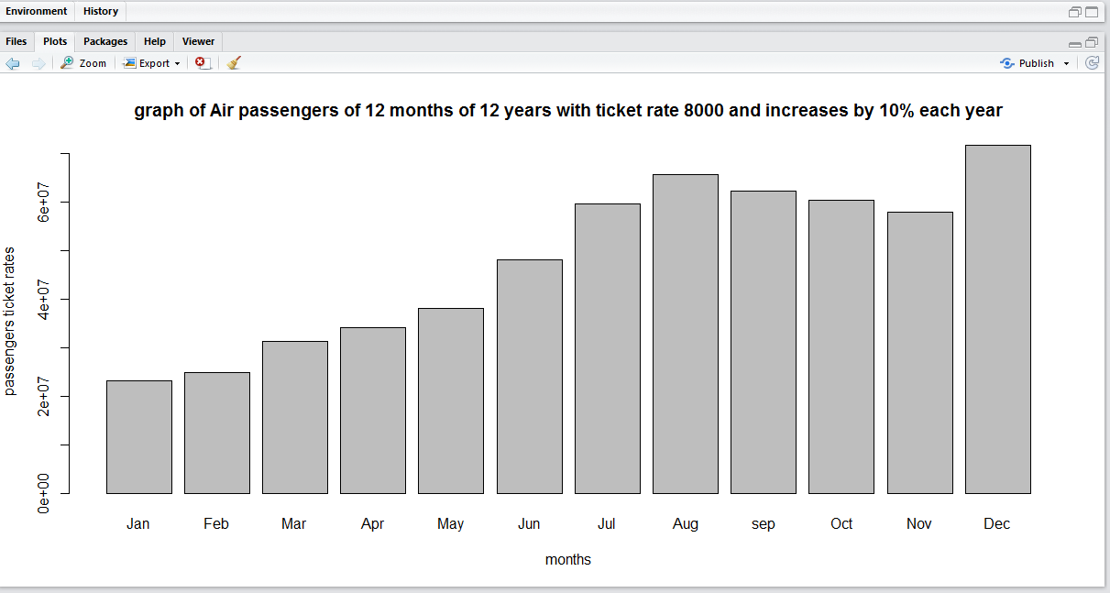

(b)

data("AirPassengers")

AP <- AirPassengers

AP

#extracting each row and calculating the sum of each row and storing

in variables

AP[1:12]

a<-sum(AP[1:12])

a

rate=8000

aa<-a*rate

AP[13:24]

b<-sum(AP[13:24])

b

rate<-rate*1.1

bb<-b*rate

bb

AP[25:36]

c<-sum(AP[25:36])

c

rate<-rate*1.1

cc<-c*rate

AP[37:48]

d<-sum(AP[37:48])

AP[49:60]

d

rate<-rate*1.1

dd<-b*rate

e<-sum(AP[49:60])

e

ee<-e*rate

AP[61:72]

f<-sum(AP[61:72])

f

rate<-rate*1.1

ff<-f*rate

AP[73:84]

g<-sum(AP[73:84])

g

rate<-rate*1.1

gg<-g*rate

AP[85:96]

h<-sum(AP[85:96])

h

rate<-rate*1.1

hh<-h*rate

AP[97:108]

i<-sum(AP[97:108])

i

rate<-rate*1.1

ii<-i*rate

AP[109:120]

j<-sum(AP[109:120])

j

rate<-rate*1.1

jj<-j*rate

AP[121:132]

k<-sum(AP[121:132])

k

rate<-rate*1.1

kk<-k*rate

AP[133:144]

l<-sum(AP[133:144])

l

rate<-rate*1.1

ll<-l*rate

sumOfY <- c(aa,bb,cc,dd,ee,ff,gg,hh,ii,jj,kk,ll)

sumOfY

barplot(sumOfY, main="graph shows the highest revenue year in the 12

years of operations", xlab="Years", ylab="revinue",

names.arg = c("1949",

"1950","1951","1952","1953","1954","1955","1956","1957","1958","1959","1960"))

Graph

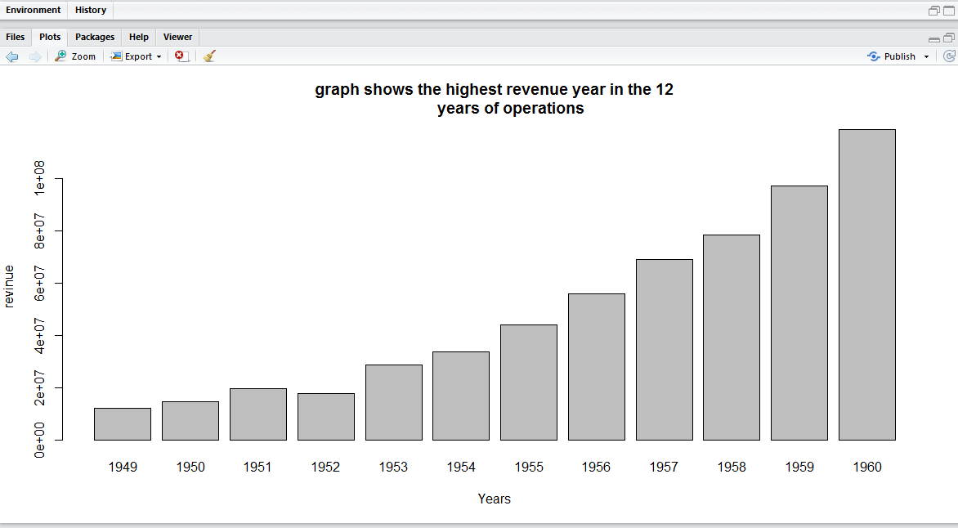

The most profitable year is 1960 in which the most of profit is earned

(c) the total revenue for the 12 years

sumOfY <- c(aa,bb,cc,dd,ee,ff,gg,hh,ii,jj,kk,ll)

sumOfY

total<- aa+bb+cc+dd+ee+ff+gg+hh+ii+jj+kk+ll

Total